TECHNICAL REQUIREMENTS

FOR THE

ALLEN PWC OLS ATP OiL Level Test bench automation

ALLEN AIRCRAFT PRODUCTS, INC.

REPORT #250129

PREPARED BY: Rick Ales, R. Ales Consulting LLC

Name, Title

APPROVED BY:

Name, Title

ALLEN AIRCRAFT PRODUCTS, INC.

RAVENNA, OHIO

Revision History

|  |  |  |  |
| --- | --- | --- | --- |
| **Rev** | **Notes** | **By** | **Date** |
| Draft 1 | Initial Draft | R. Ales | 2024/02/07 |
| Draft 2 | User Case 5: Changed the Test method to more align with current ATP procedure.  5.1.4 Change pump controller to three speed servo. | R Ales | 2024/23/07 |

Table Of Contents

Paragraph Page 1.0 2

2.0 Introduction 2

2.1 Reference Documents: 2

2.2 Notation 2

3.0 Allen Aircraft Product LabVIEW Program: 2

3.1 Allen Aircraft Products Agile Project Management Glossary: 2

3.2 Quality System AS9100 3

4.0 User Story EPIC 1 3

5.0 User Story EPIC 2 3

5.1 Production User Objectives 3

5.1.1 INPUTS: 3

5.1.2 OUTPUTS: 3

5.1.3 HMI: 4

5.1.4 Pump control 4

5.1.5 Test Status/progress 4

5.1.6 Test Report 4

5.2 Engineering/ Maintenance User 4

5.3 Use Case 1: Load Test Plan -- Maintenance User 5

5.4 Use Case 2: Validate Test System -- Maintenance User 5

5.5 Use Case 3: Read Test Configuration -- Production Test User 6

5.6 Use Case 4: Initialize DUT test -- Production Test User 6

5.7 Use Case 5: Run DUT Test -- Production Test User 7

5.8 Use Case 5: Generate DUT Test Report -- Production Test User 9

2. Introduction

The following document sets forth the requirements automating tests on production units of the Allen 8005571.05 (P&WC 30Y0241-01) Oil Level Sensor In particular the Oil Level Test Bench according to the protocol defined in ACCEPTANCE TEST PROCEDURE FOR ALLEN 8005571.05 (aka Elevation OLS ATP).

* 1. Reference Documents:

ACCEPTANCE TEST PROCEDURE FOR ALLEN 8005571.05, Report# 200333

* 1. Notation
* Means Informative
* Means Requirement

LV Means LabVIEW

AAP Means Allen Aircraft Products

ATP Means Acceptance Test Procedure

OLS Means Oil Level Sensor

1. Allen Aircraft Product LabVIEW Program:

Elate OLS level rig DAQ970 data acquisition.

Elate OLS level rig with Oil Tank manual control.

Elate OLS level rig with Oil Tank automatic control (PID) and Post test data analysis.

EPIC 4: (TBD) Elate OLS level rig with linear actuator automation.

* 1. Allen Aircraft Products Agile Project Management Glossary:

[**Agile:**   Project management](https://www.atlassian.com/work-management/project-management) as an iterative approach to delivering a project, which focuses on continuous releases that incorporate customer feedback.

**Epic:** Project as part of a program defined by one or more User Stories.

**User Story:**  Description of the end goal of an Epic from the user’s perspective.

**Use Case:**  Describe the system or user steps of a process to generate testable requirements that can be turned into executable tasks.

**Backlog:** List of tasks derived from Use Cases

**Scrum:**  Sprint meeting to prioritize task execution from the backlog and plan deliverables.

**Sprint:**  Small work cycle or iteration intended to execute Scrum tasks and deliver content.

**Kanban board:**  Planning tool to visualize the work in progress divided into stages, typically Requirements Definition; Design, Develop. Test, Release.

**Standup:** Frequent, brief meeting to address immediate needs to execute the Sprint.

**Sprint review:**  Meeting to approve transition to next Sprint by verifying the completion of Sprint deliverables.  (Developers merge branch into main, Test new main code.)

* 1. Quality System AS9100

Do we need an SOP and Work Instruction to be AS9100 compliant for:

* Release and version control should be handled like CNC G-Code (from Dragan)?
* WI for SW development style guide.?
* SW development procedure?
* How do we do Document control

1. User Story EPIC 1

NA

1. User Story EPIC 2

Description of the end goal of a sprint from each user’s perspective.

* Production User or Engineering /Maintenance User
  + Shall have a login to set user mode to either Test or Maintenance mode.
  1. Production User Objectives

1. Wants to automate the Elevate OLS (Oil Level Sensor) ATP Test.
2. Add investigatory level switch point measurement.

* + 1. INPUTS:
* 8 Ch +/-10Vdc Resistance Measurements from DataQ DI-2108
* Parallel measurements between 4 (or more) DUT (Device Under Test
* Keyence LK-G series Laser Level sensor.
* See Hardware Diagram
* Hardware status shall be indicated as Good=Green; Bad=Red; Needs attention/configuration or not automatic = Yellow i.e. calibration due (nice to have?)
  + 1. OUTPUTS:
* DataQ Digital Output to H-Bridge, FWD, REV, Brake
* H-Bridge: Vin = 12Vdc @ 5A (set for flow rate), Pump Drive signals
  + 1. HMI:

Test configuration wizard prompt for:

* Test Parameters (Excel Test Plan)
* Test Name = Job Number + Unit number (User input)
* Install DUT, Continuity test Resistance < Infinity.
  + 1. Pump control
* Fill Button ON/OFF (LV input)
* Drain Button ON/OFF (LV input)
* The Pump will have 3 speeds, FAST, SLOW and Creep.
  + 1. Test Status/progress
  + Level, Ch A & Ch B both digital readout and chart. (HMI)
  + Pass/Fail Indicator for each switch level.
  + Value of Level when switch actuated.
    1. Test Report
  + Test Configuration & Name
  + Level, Ch A & Ch B
  + Pass/Fail Indicator per ATP
  + Value of Level when switch actuated.
  1. Engineering/ Maintenance User

1. Wants to update/add test program parameters by saving a new XL Test Plan.
2. Wants to calibrate the test bench.
   1. Use Case 1: Load Test Plan -- Maintenance User

* Document management
  + The test plan shall be an XL workbook named to be traceable the test protocol implemented.
  + The test plan shall be version controlled in the Test repository per AAP QUAM.
  + There shall be a means to add/include the test plan path into the user prompt.
* Enter the test bench configuration parameters into XL test plan.
  + The test plan shall contain the configurable test bench parameters as determined by the test bench design.
* Tabular data should be a copy and paste operation from the reference Test Document (ATP) into the XL Test Plan document for loading as a LV parameter.
* Enter DUT specific configuration parameters into XL test plan. Eventually the test plan may include variations of the test protocol that are run at different stages of production. For example, pre-pot test the DUT has no connector, post-Pot is the Actual ATP.
  + The test plan shall contain the referenced test protocol test bench parameters as determined by the test bench design.
  + It should be a copy and paste operation to include the Test bench parameters into the XL Test Plan document.
  + The Test Plan shall contain a template of each test report generated on a separate sheet in the test plan XL workbook.
  + The test plan shall be capable of containing multiple templates to accommodate recording multiple test points or variations of test protocol.
  1. Use Case 2: Validate Test System -- Maintenance User
* Calibration Procedure
  + There shall be a means to perform a 2-point mx+b calibration on each AI input. (wizard?)
  + There shall be a means to perform a 2-point mx+b calibration on each Level Sensor (wizard?)
  + These Bench calibrations shall be saved /linked to each Test Plan.
* Troubleshooting Aids
  + There shall be a means for manually setting the tank level.
  + Each instrument (DataQ, Keyence) shall provide a health indictor.
* There shall be a simulate mode that provides simulated instrument input and Level response to be used with debugging.
* There shall be a test vector mode that reads and process AEPS test data to validate the system processing algorithm.
  1. Use Case 3: Read Test Configuration -- Production Test User
* LV program must launch from PC desktop ICON.
* Maintenance User exclusive controls and Indicators shall be hidden in Test mode.
* All Test Parameters options must be presented in the form of a discrete choice (i.e. dropdown, pick list, radio button etc.).
* Path to valid XL test plans shall be saved in LV as constant (Register Key??) and presented as a choice by Test name configured by the Maintenance User.
* The system shall be configured and initialized and shall report any NOT READY to test status: i.e. no functional instrument, out of calibration data, error reading test Plan etc.).
  1. Use Case 4: Initialize DUT test -- Production Test User
* There are buttons to run operate the bench, but we think there should be wizard that walks the Tester through but can be disabled by an experienced user. The wizard is of lower priority but sequenced here to illustrate how the test is expected to be run.
  + There shall be a means to disable the wizard. (ie do not show again/show wizard)
  + The user must have a means to select from multiple variants of the same test.
  + The user must have a means to indicate that the test is a run of an already conducted test.
* Load DUT identification information
* There must be a Prompt to enter DUT routing job number which shall be a text string.
* There must be a Prompt to enter DUT sernum for each DUT.
* The routing and ID input shall be displayed and request conformation, in the form of an “are you sure?” type prompt with a YES, NO choice response. On NO reply, the user must be able to update that input which shall be retained but editable.
* Each DUT shall be identified as <Job#>&”- “&<DUT_sernum>.
* Load DUT into the test bench.
* There shall be a prompt to load DUT serial num into assigned test cell position then press OK to continue.
* On the OK response, each cell with a DUT unit must be checked for continuity (<infinity ohm reading).
* The user shall be prompted to fix any issues such as empty expected DUT cell.
* When no Ready for Test is detected, the user shall be prompted to include any opening notes or annotations.
* The user shall be prompted to Start the test.
  1. Use Case 5: Run DUT Test -- Production Test User
* The Test protocol shall implement the ACCEPTANCE TEST PROCEDURE FOR ALLEN 8005571.05, Report# 200333. (attached)
* Figure 2 defines the characteristics of the nominal electrical signal during filling about the 200=300 ohm transition.
* Figure 3 Illustrates the nominal electrical signal step function over the full drain to fill cycle. (bold red curve). The pulses represent the minimum and maximum “set points” referenced in Table 1 & 2 of the ATP. This region is the Switch Zone. In the low areas showing the expected resistance measurement is the R Measurement Zone. The Resistance is monitored in the R Measurement Zone as a diagnostic but not reported as part of the ATP.
* Figure 4 shows the modified state transition diagram for the Automated ATP; .

Figure 2 Test point definition per ATP Spec

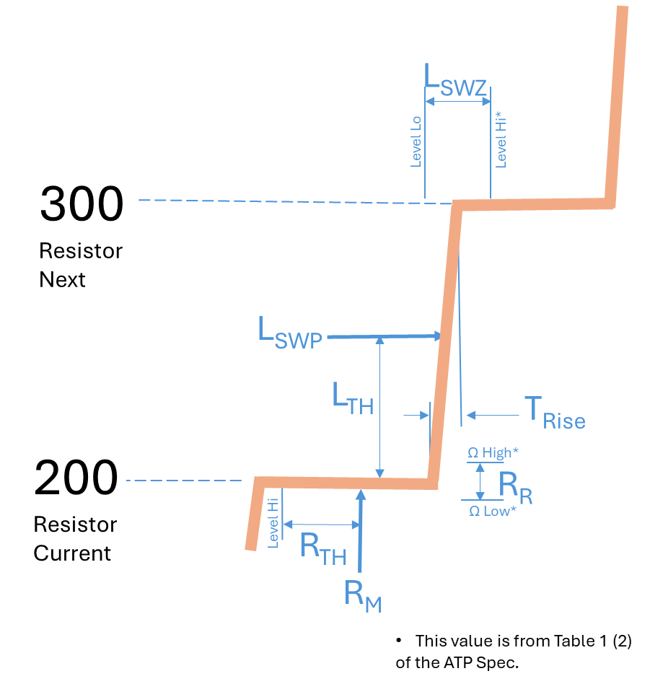

WHERE:

**LSWP**Level Switch Point - The next Level measurement after the Resistance measurement is grater than LTH when Filling.

**LTH**Level Threshold – Average of Resistance Requirement at current level and Resistance Requirement at the next level.

**LSWZ**Level Switch Zone - From Table 1 (2) Range **LSWP** must be between for Level to pass.

**TRise**Rise Time - The time measure between from 110% of Current **RM** to 90% of the Next **RM**

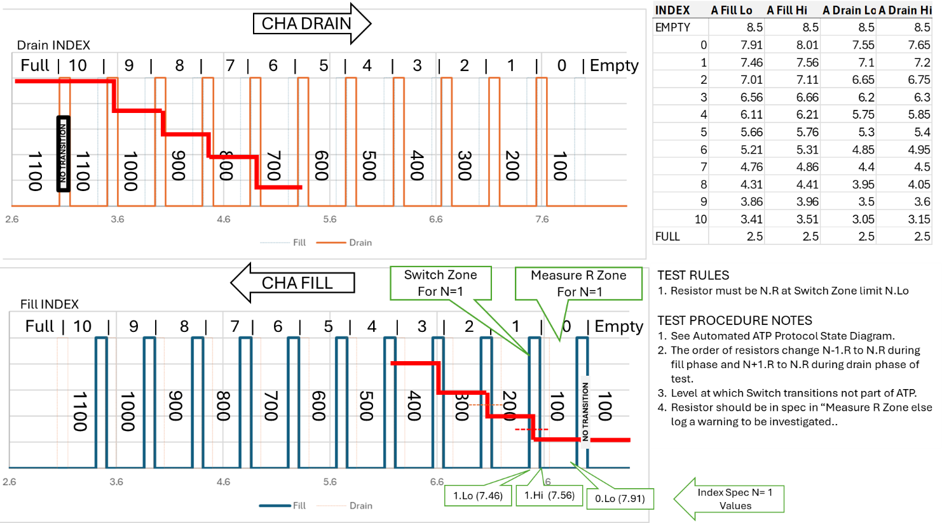

Figure 3 Illustrated Drain-Fill cycle

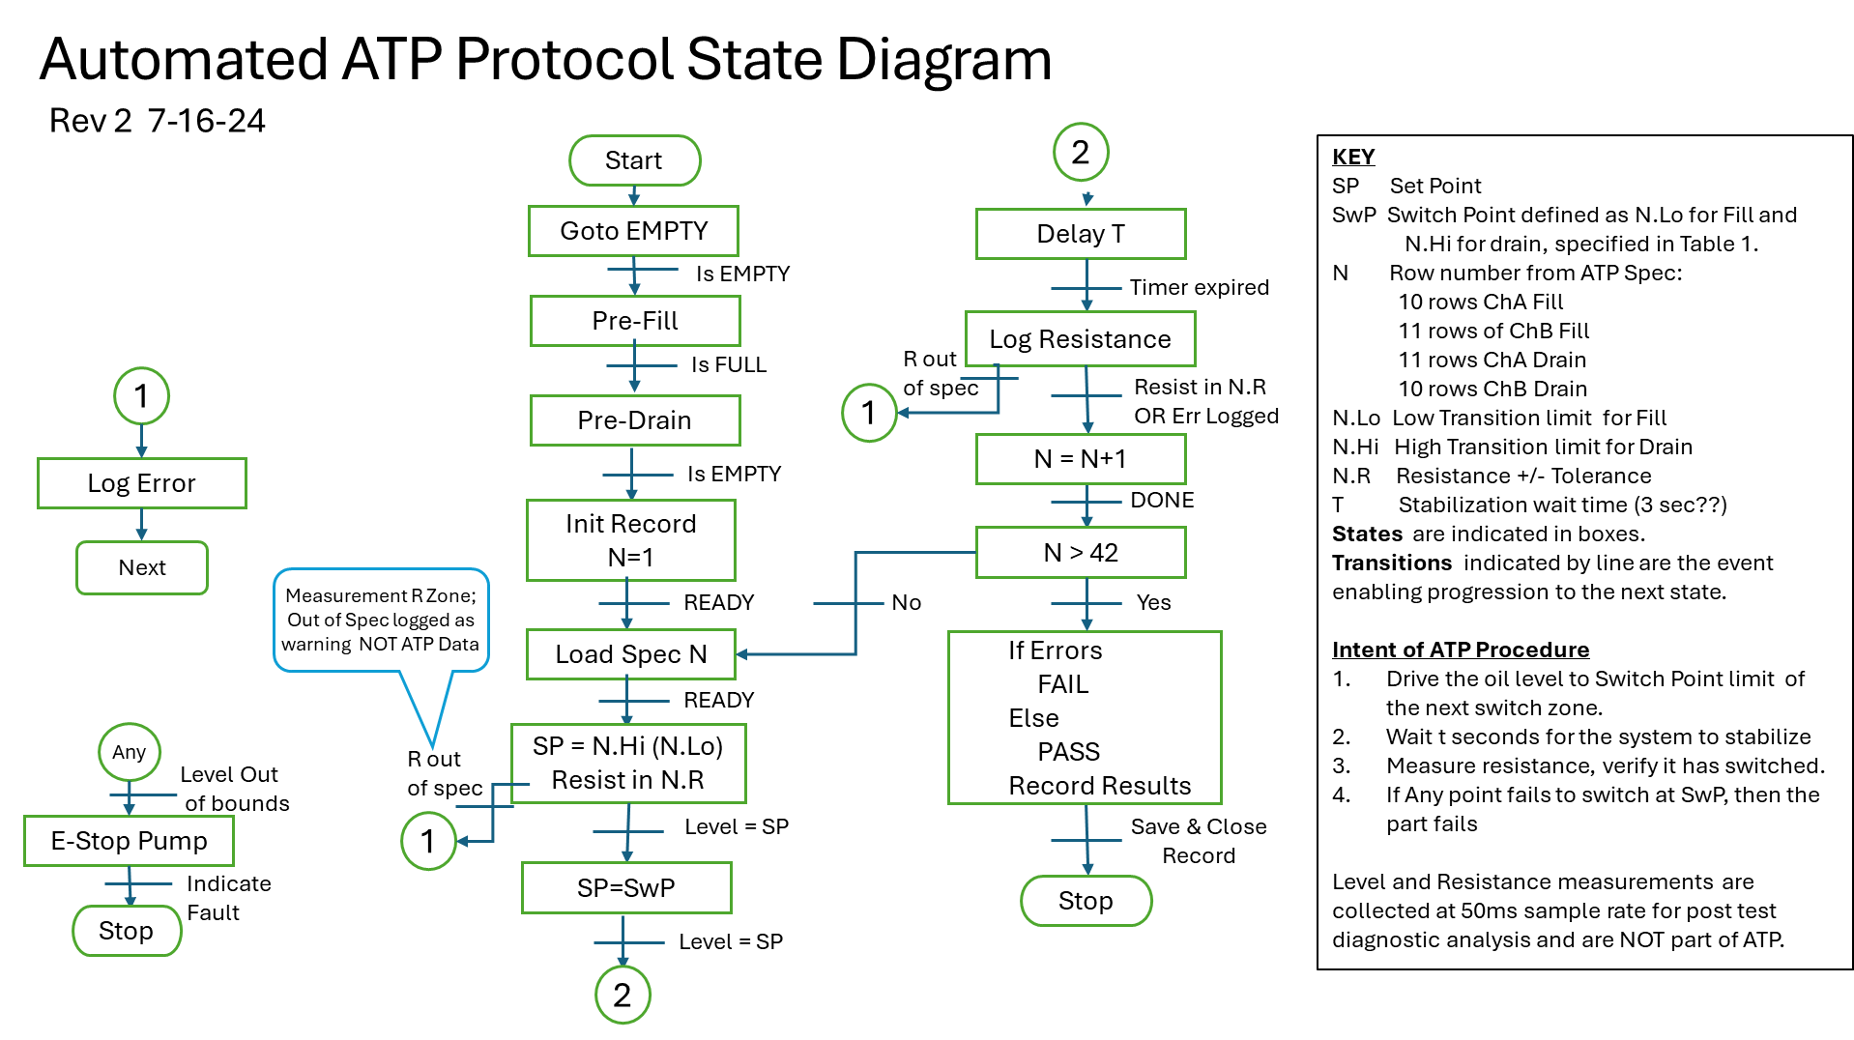

Firgure 4. Automated ATP State Transition Diagram

* + The Automated ATP is based on the spec, and these 3 figures.
  + The oil level shall be cycled from full to empty prior to testing.
  + The oil level shall be filled from empty to the Low Fill Limit and wait 3 seconds.
  + The Resistance shall be measured. If in tolerance the test at this level is OK, else an Error Shall be logged.
  + The above two steps are repeated for each Low Fill Limit.
  + The oil level shall be drained from full to the High Drain Limit and wait 3 seconds.
  + The Resistance shall be measured. If in tolerance the test at this level is OK, else an Error Shall be logged.
  + The above two steps are repeated for each High Drain Limit.
  + The DUT shall be recorded as PASS if no errors are recorded.
  + Currently with one DataQ (8 channels will) will monitor 4 sensors, but the tank is fixtured to accommodate 12 sensors. One DataQ for 4 sensors.
* Multiple DUT units shall be tested per test cycle (level min-max-min cycle)
* The test status shall graphically display Ch A & Ch B resistance in ohms and display the Level in inches.
* All three traces shall be scaled so they are presented overlayed at a similar size. The Chart scale is configurable test parameter.
* A display shall indicate each Switch status as NOT TESTED (gray), PASS (green) or FAIL (red).
* A display shall indicate the level value upon actuation on FILL and actuation on DRAIN.
* The User must have the means to monitor the Test bench health during testing.
* Users must have a means to PAUSE the test.
* Users must have a means to ABORT the test.
* Users must have the option to RERUN the test.
* Users must have the option to run the level in manual or automatic modes.
* The default test mode is automatic.
  1. Use Case 5: Generate DUT Test Report -- Production Test User
* There shall be one XL workbook for each job number named the Test Procedure concatenated with the Job number.
* That shall be one sheet to contain the results for one test run of each DUT.
* The sheet shall be named the variation of the test concatenated DUT_ID
* The sheet shall be derived from the template contained in the XL test plan for the appropriate variant of the test.
* The XL Test Plan shall contain a test log of
* User must acknowledge/approve saving acquired data to Test Report.
* The path of the test report repository shall be configured by the Maintenance user.
* The user cannot change the test report or the test repository path.
* The user shall be prompted for any additional closing notes or annotations to be included.
* The first Sheet of the test report shall include Job number as Title, PRE and POST test annotations input by the user and the actual test bench configuration values for the test run.
* Each DUT test report sheet shall contain tables for each switch of:
  + Ch A Fill: in Range? Pass/Fail; Level Value of actuation.
  + Ch B Fill: in Range? Pass/Fail; Level Value of actuation.
  + Ch A Drain: in Range? Pass/Fail; Level Value of actuation.
  + Ch B Drain: in Range? Pass/Fail; Level Value of actuation.
* Each DUT test report sheet shall contain Graph of Ch A Ch B and Level over the whole test.
* Do we want to keep a test log, perhaps as a sheet in the Test Plan that list the Job Number and general Pass/fail status?

Proposed Elevation OLS Test Bench Control Hardware

Front panel concept

XXXX